**PROJECTREPORTTEMPLATE**

**JOBAPPLICATIONSTRACKINGSYSTEM**

**INTRODUCTION**

OVERVIEW

Job applications tracking system software can come equipped with capabilities ranging from simple database functionality to a full-service suite of tools that makes it easy for businesses of any size to filter, manage, and analyze candidates.

PURPOSE

The primary goal of an Applicant Tracking System is to simplify the recruitment process and to make It more effective and efficient. This is accomplished by giving recruiters access to a powerful, centralized platform to collect and view applicants, track their progress, and filter them out based on their qualifications.

**PROBLEMDEFINITIONANDDESIGNTHINKING**

EMPATHYMAP

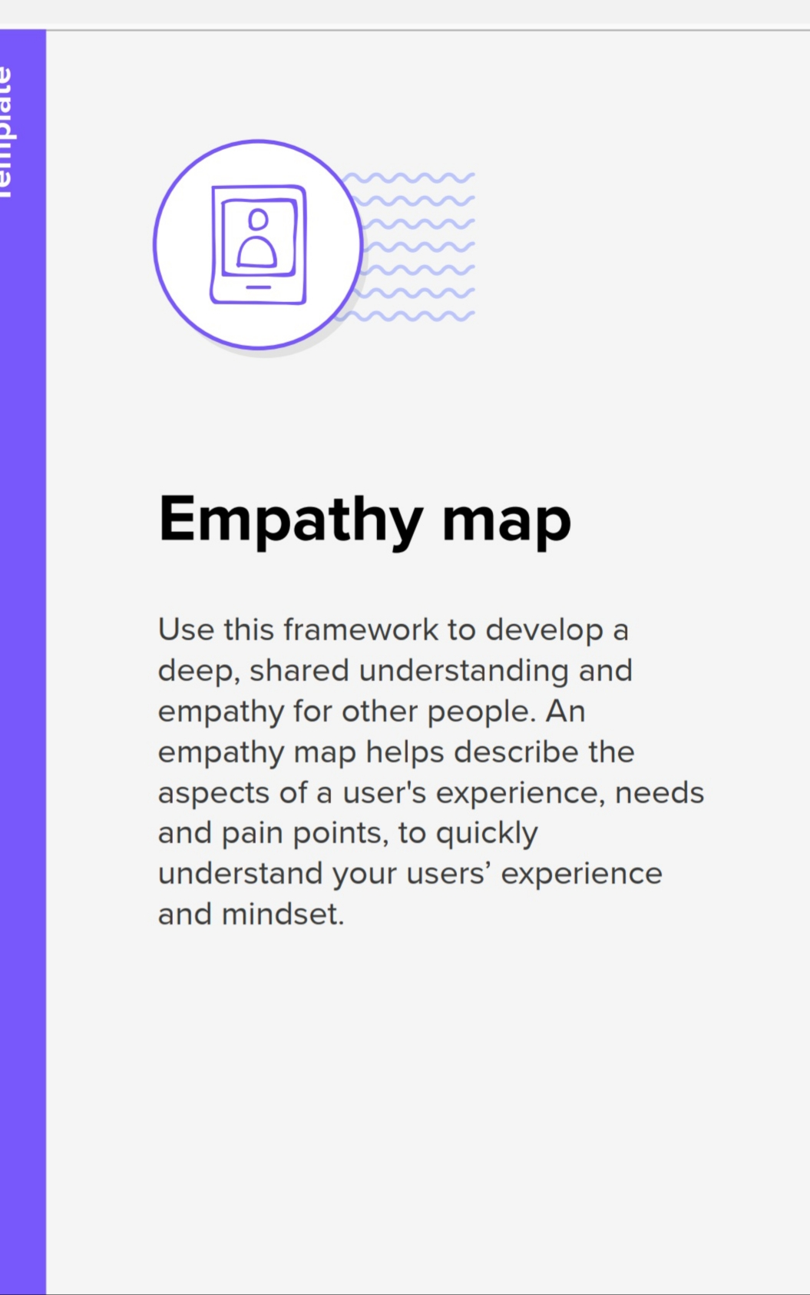

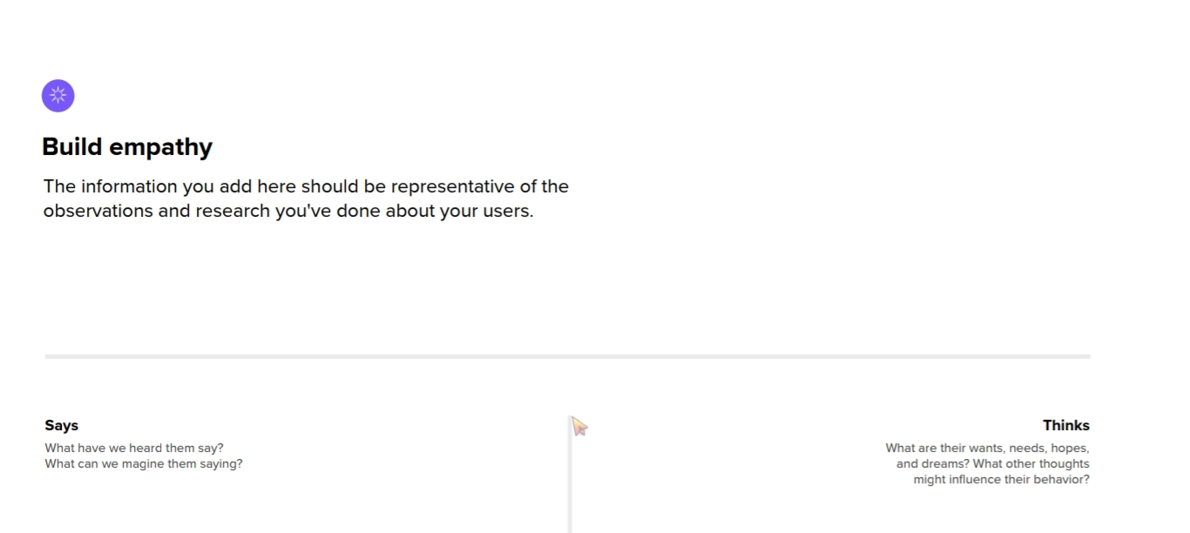

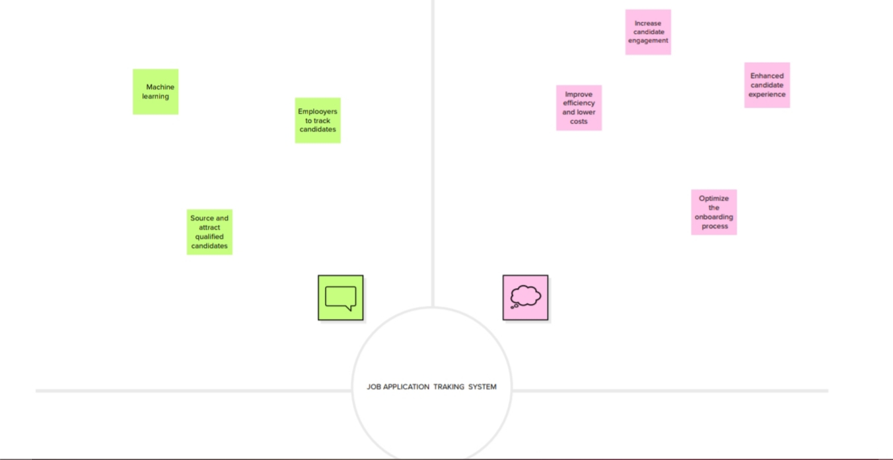

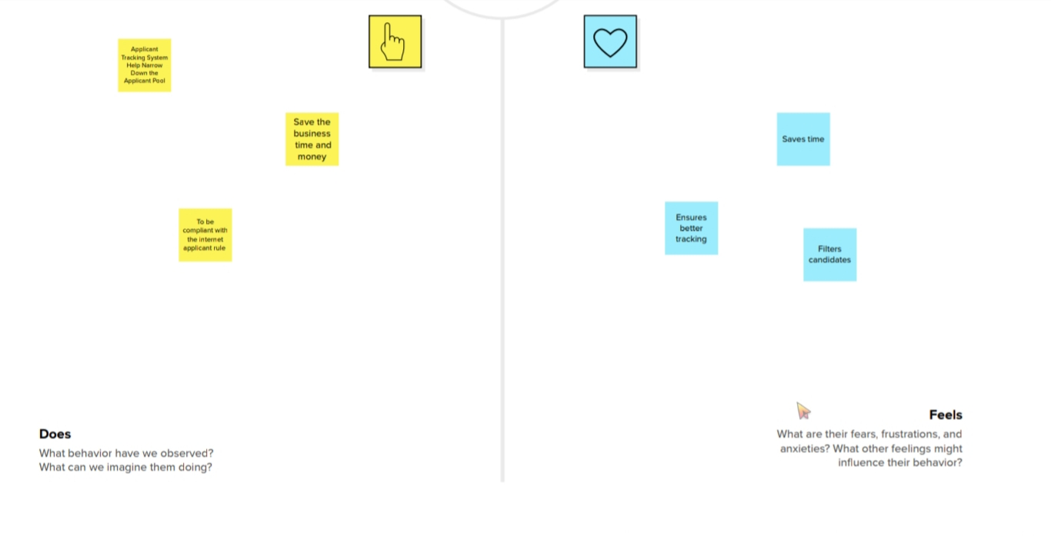

IDEATION AND BRAINSTORMING MAP

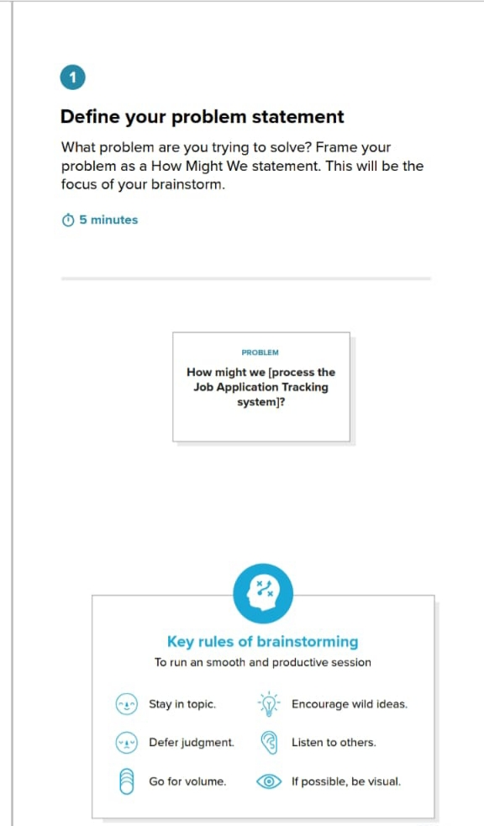

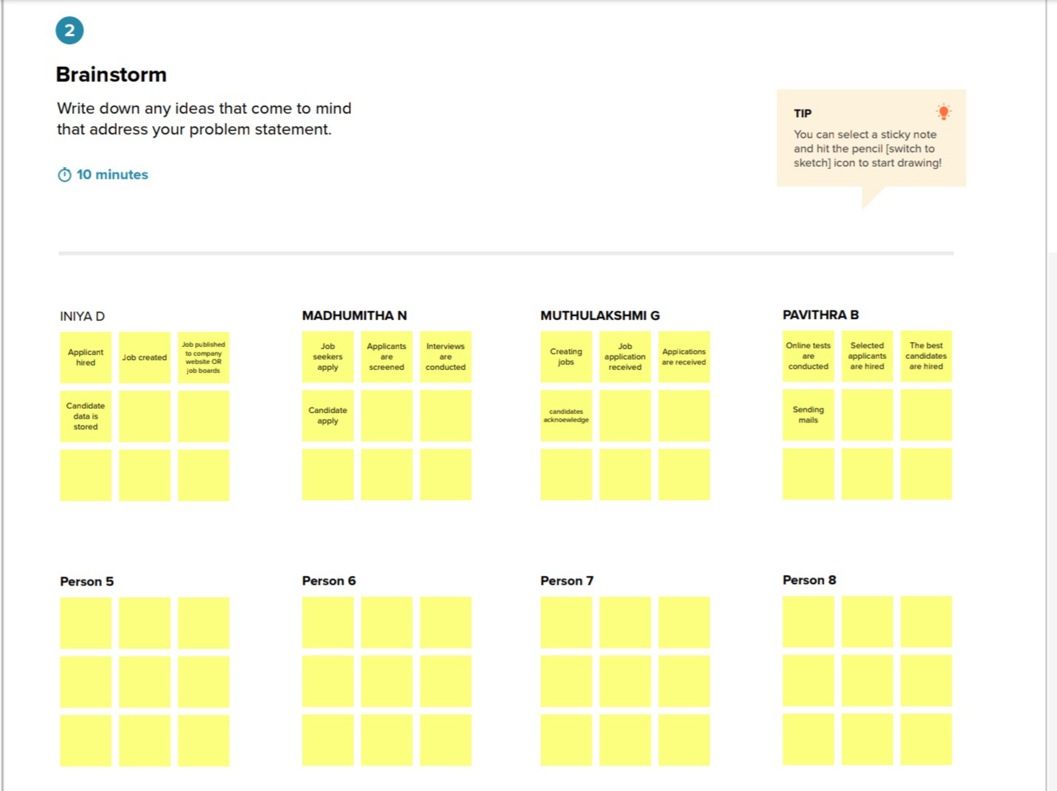

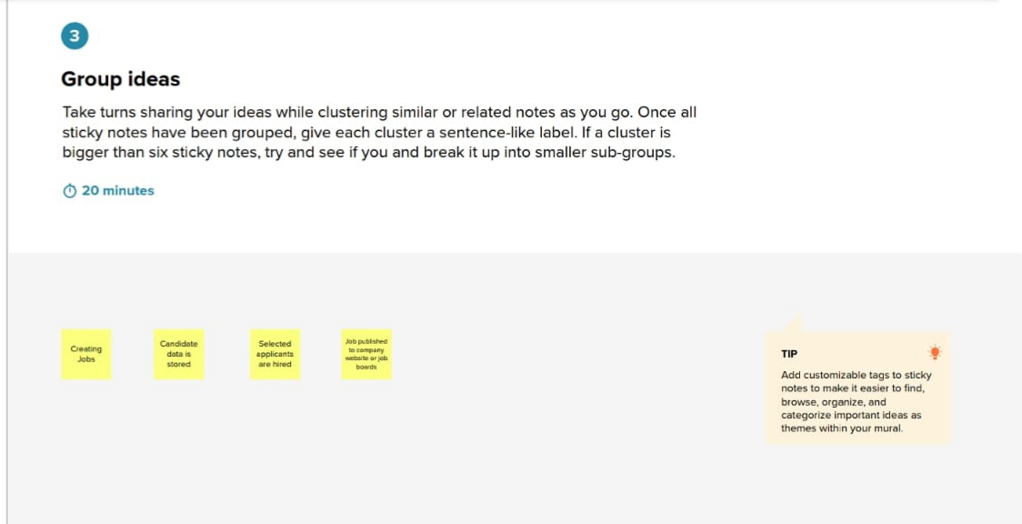

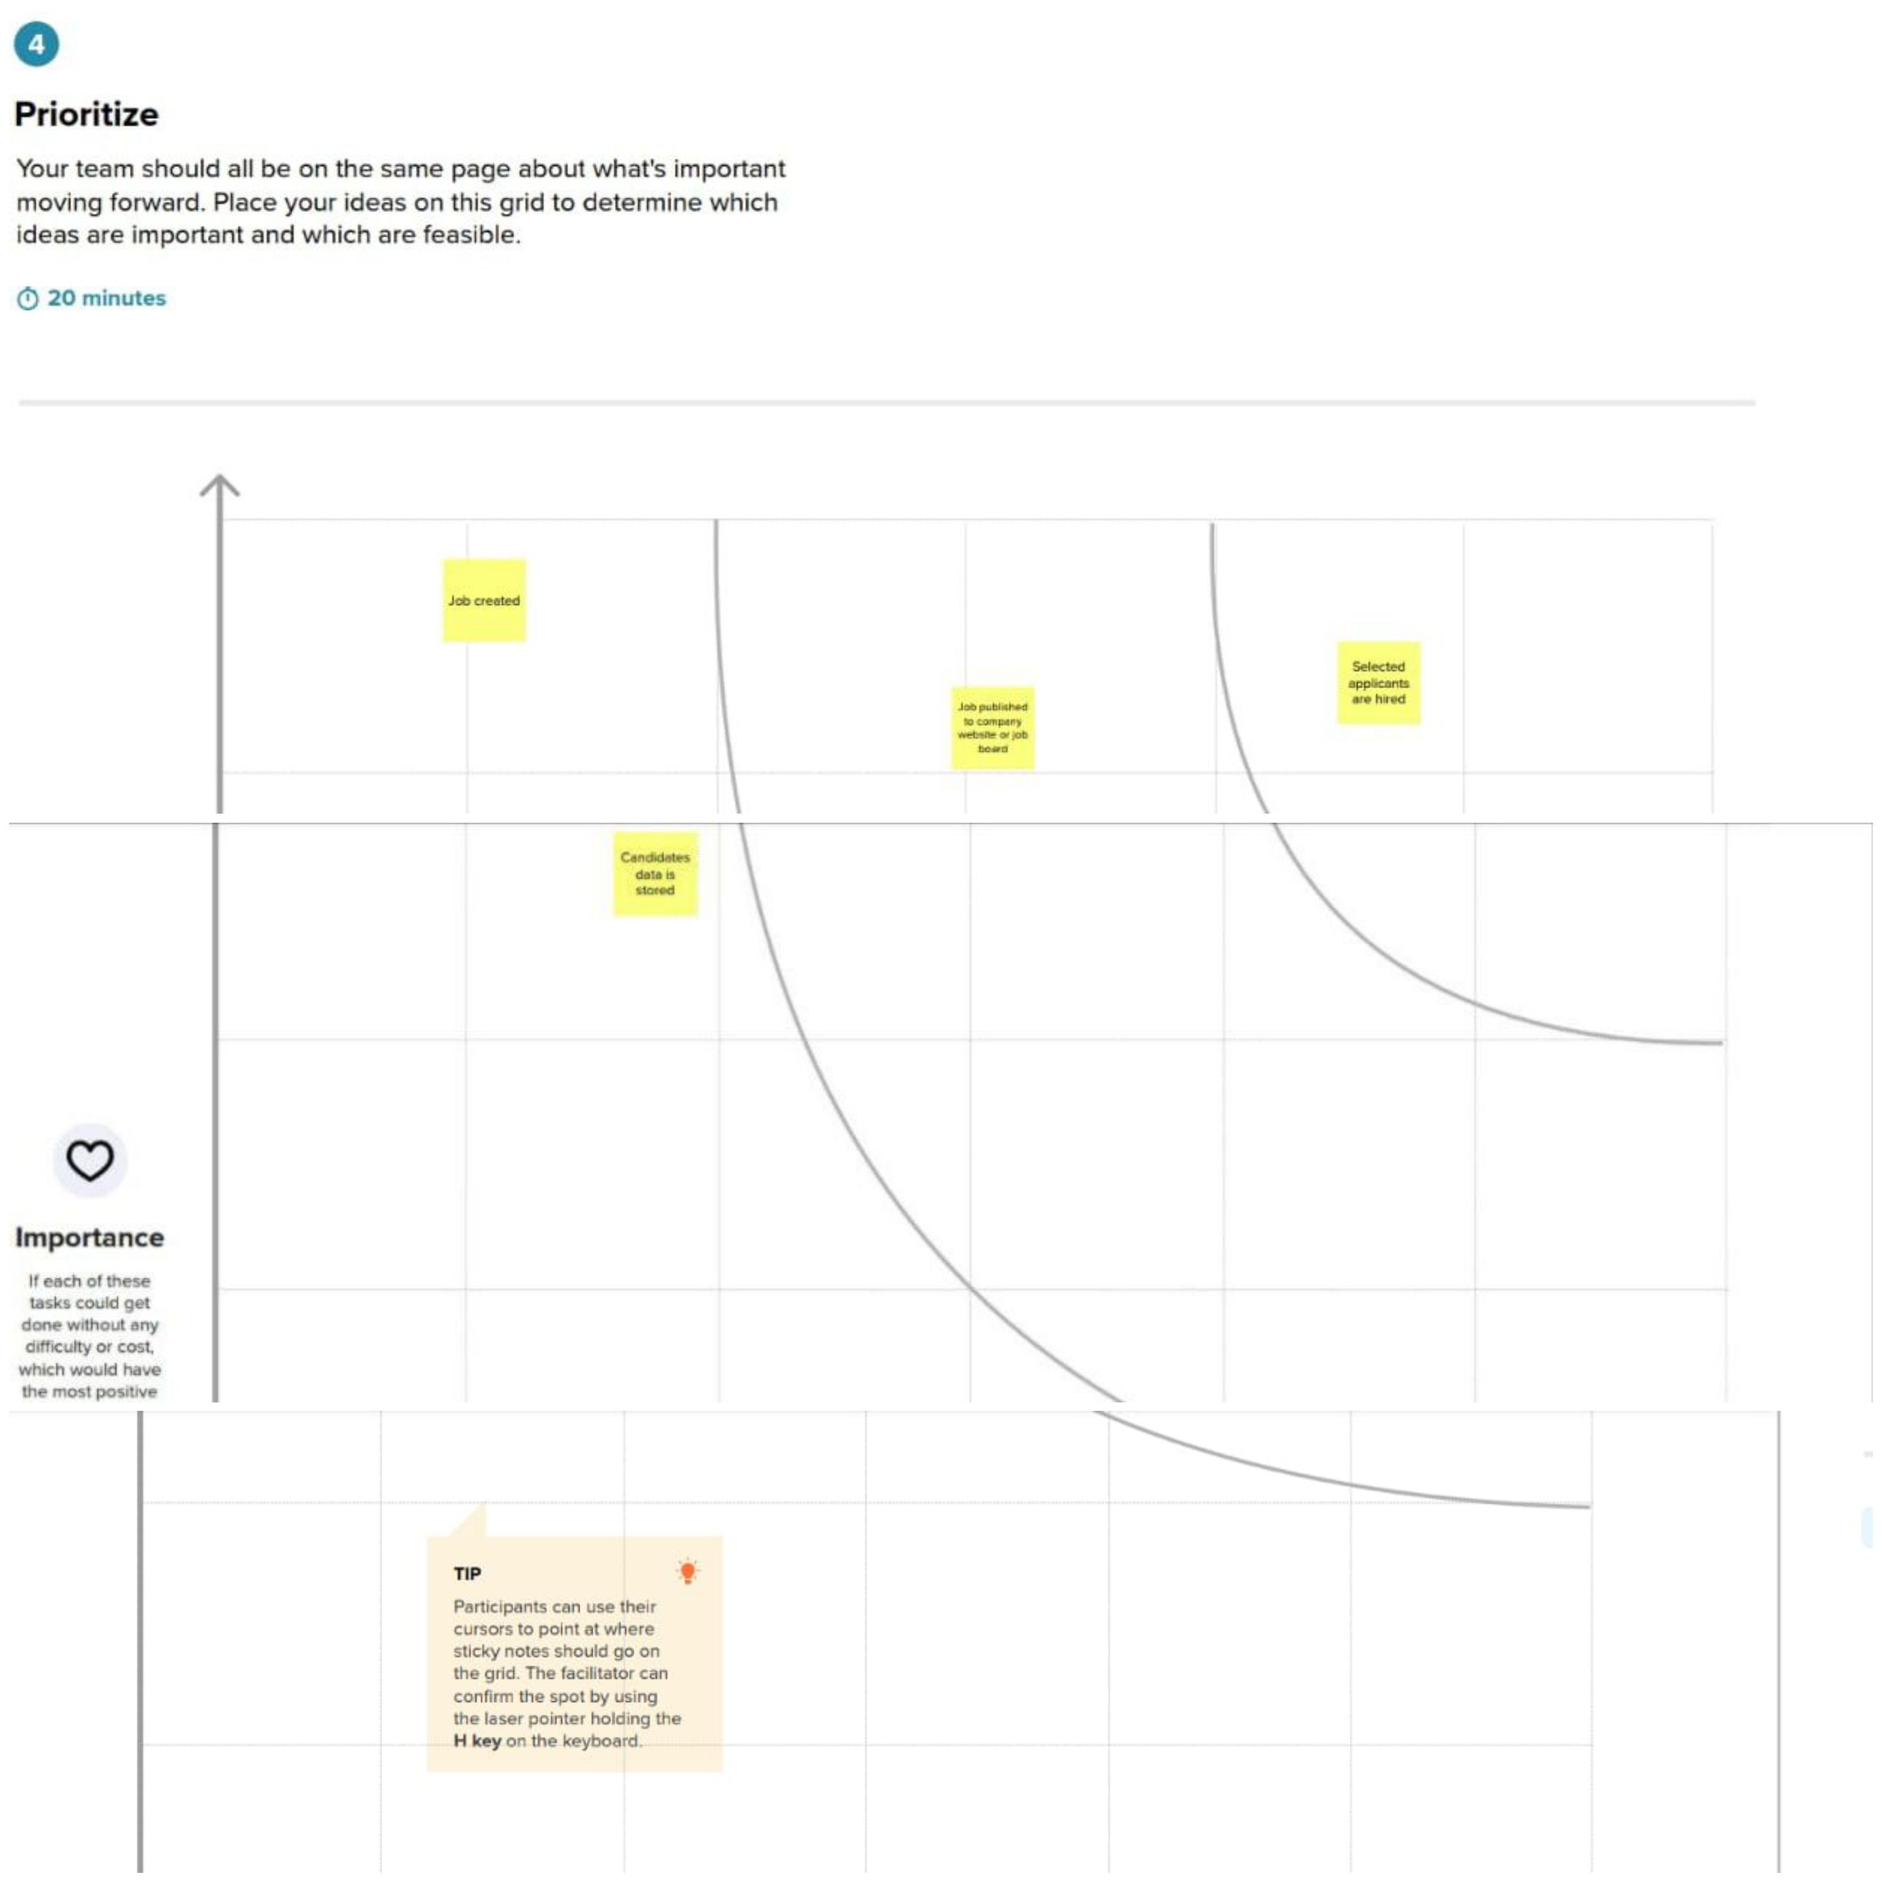

**RESULT**

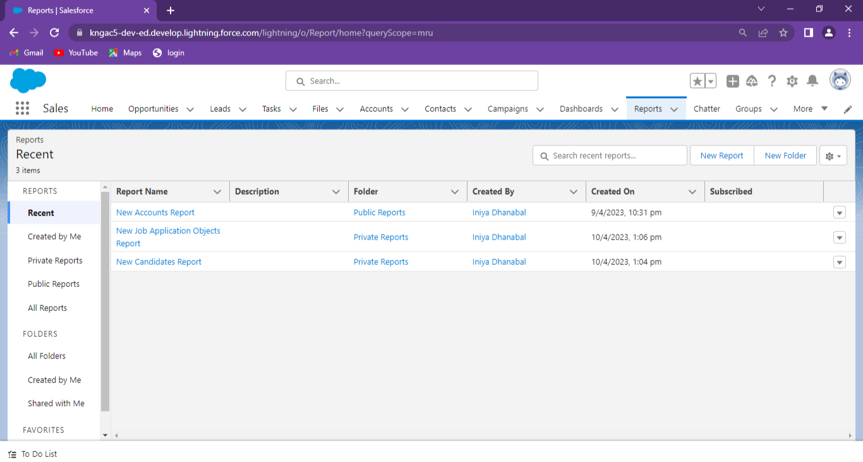

**ADVANTAGES AND DISADVANTAGE**

ADVANTAGES

* Save time on administrative tasks
* Host an attractive career a page
* Make it easy apply from the device
* Increase your applicant pipeline
* Track your applicant source
* Make quality hires consistently

DISADVANTAGE

* A Disadvantage of Job applications tracking system is missing qualified applicants due to wrong keyword selection.
* Automatic elimination of resumes that software cannot recognize and interpretisan other drawback of Job applications tracking system.
* A Job applications Tracking System Disadvantage is that they are open to manipulation.

**APPLICATIONS**

* If you’re applying toalarge organization, you’ll most likely face an ATS.
* If you’re applying through any online form, you’re applying through an ATS.
* Even job sites like Indeed and Linked In have their own built-in ATS.

**CONCLUSION**

* Applicant Tracking System for recruiters is a very effective hiring solution that most of the successful recruiters utilize.
* Because without tit , there is a good chance that your process of moving applicants through different tages can be come very difficult.

**FURUTURESCOPE**

* In the future, these system sare expected to be more fully integrated with social media platforms like Linked In.This will enable them to identify both active and passive candidates who area good match for open positions.
* Additionally, AI-powered chatbots could be used to answer questions and provide information about the application process.

**APPENDIX**

